1.     Rank employees by their total sales

(Total sales = Total no of orders handled, JOIN employees and orders table)

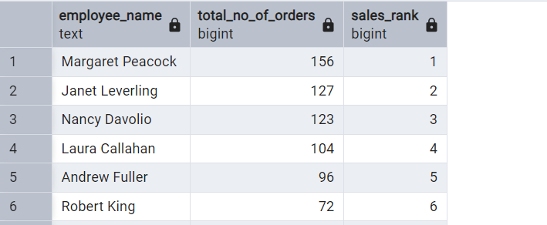

2.      Compare current order's freight with previous and next order for each customer.

(Display order_id,  customer_id,  order_date,  freight,

Use lead(freight) and lag(freight).

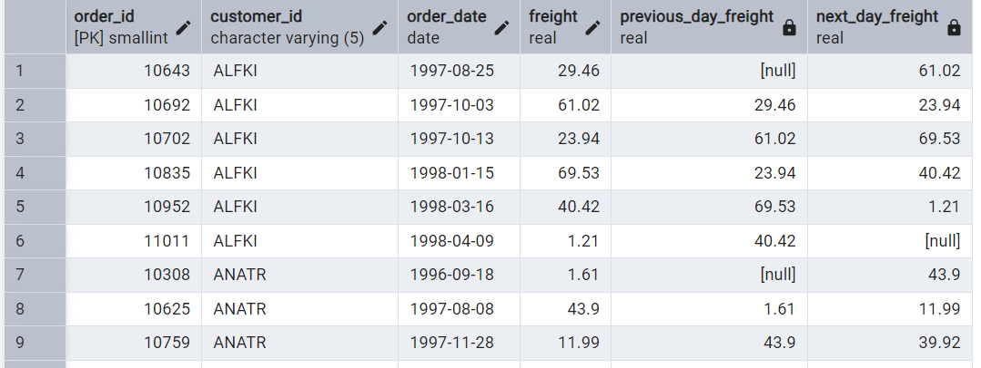

3.     Show products and their price categories, product count in each category, avg price:

